# PETSTEP: 3D PET simulator

## Description

This tool allows the generation of simulated PET images with inserted lesion. The CERR window needs to be open with a registered CT and PET (or PET uptake map), and one or more contours drawn on one of the scans. Once simulated, the PET image is appended to the current planC.

A detailed description of the tool can be found at XX

## Starting the simulation

1. Start the simulation by selecting the “PET simulator” option from the PET-STAT menu as shown on Figure 1.

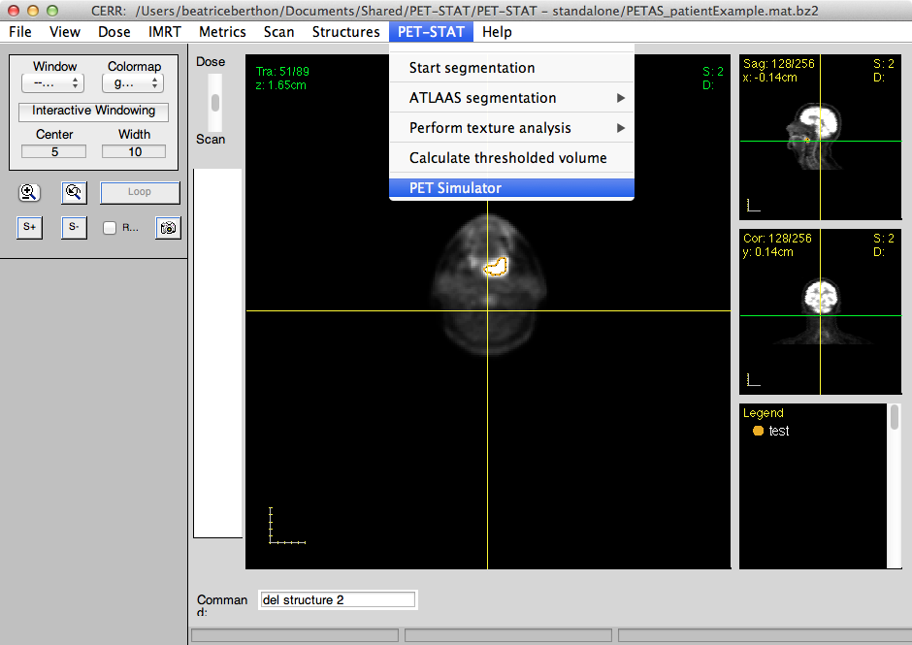

Figure 1. PET Simulator option shown in PET-STAT menu

1. On the figure appearing (cf. Figure 2) select the type of protocol to load from the listbox in the left top corner, or select “Use custom parameters” to load a protocol previously saved in a different file.

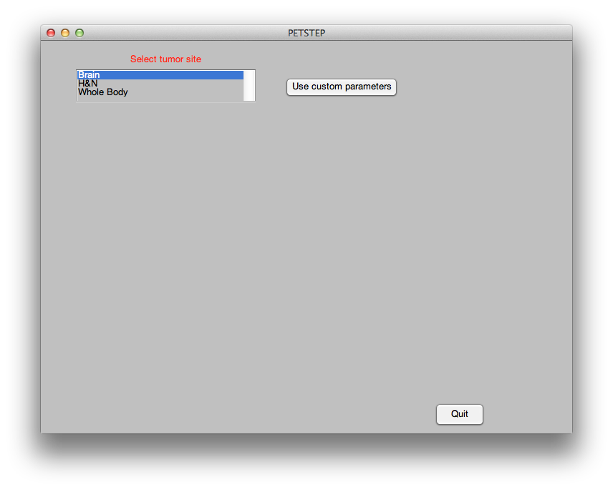

Figure 2. Window appearing when selecting the PET Simulator option from the PET-STAT menu

1. Enter and select the parameters desired for the simulation, as shown on Figure 3. These include:

* Additive uptake: check to add the uptake value specified for the tumour (‘Tumor max uptake, below) to the background uptake. Otherwise, the tumour uptake value replaces the background uptake value at the tumour location.
* PET scan as uptake map: check if a PET uptake map is used for the simulation, i.e. a 3D image corresponding to the CT with the intensity of each voxel representing the uptake value to be modeled (in Bq/mL). If this box is not checked, i.e. if a PET scan is used a an input, scatter, and random and CT-based attenuation will be applied to the tumour only.
* Tumor max uptake: maximum tumour uptake to model. Units are the same as the input PET image.
* CT % contrast above background: intensity of the tumour in CT, expressed as the percentage of background HU to add in the tumour. E.g.: a value of 12.5% means that the tumour HU will be 112.5% of the background HU.
* PSF kernel FWHM: Full width at half maximum of the scanner PSF to be modeled.
* Scan time: time of acquisition to be modeled
* Bed position overlap: scanner parameter to be obtained form manufacturer
* Activity concentration: Average activity concentration in the scanned object
* Sensitivity: sensitivity of the scanner
* Scatter fraction: scatter fraction of the scanner
* Randoms fraction: randoms fraction of the scanner
* Projection angles: extracted from the scanner specifications
* Diameter of gantry: to be obtained from manufacturer
* PSF correction kernel FWHM: it is recommended to use the same value as the PSF kernel FWHM (‘Match PSF kernel ‘ box checked).
* Reconstruction methods: check any of FBP (filtered back-projection) OSEM (Ordered subset expectation maximization) or OSEM + PSF (OSEM with PSF-correction)
* PET matrix size: Number of voxels in each dimension of PET image slices
* Post filter FWHM: size of the post filter cut-off, to be obtained form the scanner reconstruction protocol
* Number of iterations: number of iterations for the PET image reconstruction
* Number of subsets: number of subsets for the PET image reconstruction
* Axis filter weight: define filter for homogenisation of slices in the axial direction
* Number of noise realisations: enter number of PET images to be generated with these parameters. Every realization is different due to random noise added in the process.
* Load all realisations: check if the different noise realisations should be added to current planC
* Load all iterations: check if the different reconstruction iterations should be added to current planC

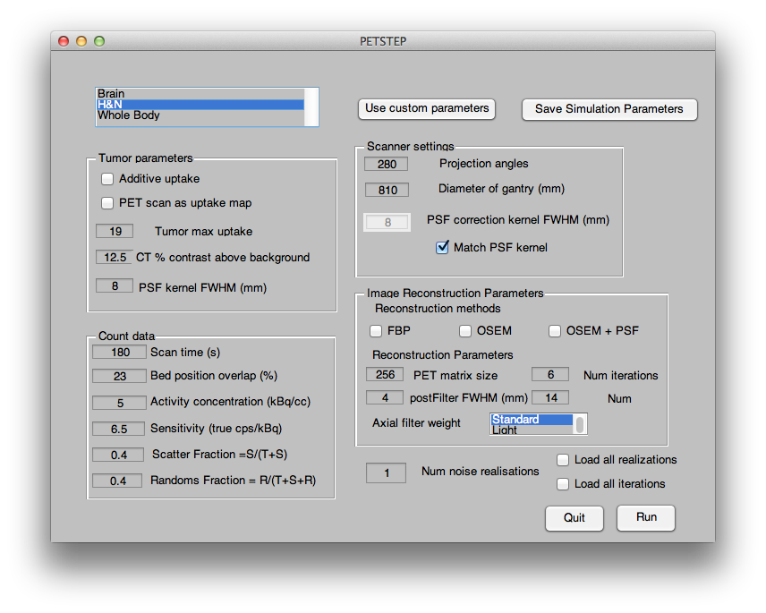

Figure 3. Parameters and settings appearing when a protocol for the PET simulator has been loaded